GED108 A2 — Museum Visit Activity
National Museum of Fine Arts (Manila) + The Metropolitan Museum of Art (Virtual Visit)
Roldan, Chever Marq L. | 2013••••••

1. Experience Essay

Opening / Context
In this assessment, I was able to experience two kinds of museums related to art: the first physically, by visiting the National Museum of Fine Arts in Manila, and the second virtually, through The Metropolitan Museum of Art in New York using Google Arts & Culture Street View. I personally did not know what I was getting into, and that was intentional. I like experiencing things without too many expectations so I can have a genuine reaction. I expected the activity to mostly be about looking at artworks, but I ended up thinking just as much about how museums are organized, how people are guided through them, and how much context is given to the viewer.

Physical Museum Experience
For the physical museum experience, I was quite surprised that the Fine Arts museum had a line outside—and it was long. For comparison, I went to the Natural History museum before this and there was a line too, but things moved quickly. For Fine Arts, I had to wait around 24 minutes to get inside. Luckily, both museums had air-conditioning, which I always appreciate because otherwise it can affect the way I judge the experience. Both museums also had a problem for me: navigation uncertainty. There was not much obvious guidance for a first-time visitor. For example, after the Spoliarium Hall there was another corridor, but I did not know whether I should go left or right. Natural History at least had a more obvious flow where the exit of one gallery often led toward the entrance of another. Maybe the Fine Arts layout was intentional, but someone who does not have much time on their hands might experience it differently.

How I Relate to Artworks
I would say I do not normally relate to artworks in the sense of seeing myself in them, but I can empathize with the fact that an artwork is a subjective product of a person. The artist was thinking about something while making it, even if I do not completely understand or agree with the result. I also do not naturally rank artworks or choose favorites because that can feel like I am imposing my own preference as a judgment. What I do appreciate is seeing the process of how things are made. Amorsolo's sketches, for example, made me think about how he observed people before turning them into finished works. I was also curious about how many paintings were oil-based and what that says about the resources, cost, and effort behind producing or commissioning them at the time.

Historical Emotion and Memory
One pattern that stood out to me was how many of the historical works carried negative emotions: war, death, suffering, displacement, violence, and trauma. Only one work struck me as clearly positive because it centered on hope. That made me wonder whether those periods of Philippine history were really experienced mainly through tragedy, or whether traumatic events are simply more likely to be painted, collected, preserved, and exhibited because people feel they need to be remembered.

Gendered Representation of Violence
I also noticed that violence seemed to be represented differently depending on gender. Women were more often shown exposed or sexually vulnerable, while men were more often tied up, beaten, restrained, or treated like physical targets. I know that men have also experienced sexual violence, so this made me question whether this difference comes from the historical realities being represented, the conventions of artists at the time, or the kinds of works that museums chose to preserve and display.

Anchor Artwork: A Tragic Lesson (The Fall of Bataan)
For the Choose–Look–Analyze–Reflect part, I used Gene Cabrera's A Tragic Lesson (The Fall of Bataan). Visually, I noticed skulls that seemed to represent not only soldiers but also civilians, women, and people identified through clothing or religious markers. The colors were dark and pale, with a green background, and the heads were arranged almost like separate windows that sometimes overlapped. The painting was made in 1957 but refers to the events of 1942, which I connect to the humanitarian disaster surrounding the fall of Bataan, including shortages and failed rescue expectations. My reaction was actually quite critical: I thought the use of skulls was a very direct and almost obvious way to represent tragedy. For me, the painting becomes significant less because the imagery is especially subtle and more because of the historical event it carries.

Virtual Museum Experience
The virtual visit felt different from the physical one in an interesting way. The Met looked very spacious even through Street View, and I liked how the artworks seemed to have their own personal space. At the same time, the digital experience was incomplete. Not every artwork had a clickable or highlighted view, and even when an artwork was identified, some of the information I expected to see beside a painting—such as the year—was missing. The physical museum made me struggle with where to go, while the virtual museum made me struggle with what information I could actually access.

Scavenger Hunt Experience
The scavenger hunt also changed the way I looked at the virtual museum. Instead of simply moving through the galleries, I had to search for very specific visual qualities: unusual clothing, animals, texture, perspective, expressions, food, and so on. Some categories were easy to match, while others were difficult enough that I reused an artwork when it genuinely fit more than one prompt. It made me pay attention to details I probably would have ignored if I were just browsing freely, although it also made the limitations of the virtual indexing much more obvious.

Conclusion
By the end of both visits, I kept coming back to the course question about why students may not enjoy art history. I do not think the problem is always the art itself. Sometimes the way the experience is structured matters just as much. In the physical museum, I wanted clearer guidance as a first-time visitor. In the virtual museum, I wanted better labeling and indexing. Both experiences still gave me something meaningful, but they also showed me that context, navigation, and presentation can affect whether someone feels curious about art or simply feels lost while looking at it.
2. Virtual Reflection Responses

Overall impression
The Met Museum in New York felt very spacious even through the virtual tour. I liked that the artworks seemed to have their own personal space rather than being crowded together.

Favorite part
I do not think I had a favorite part. The virtual tour gave me a way to look inside the museum, but not every artwork had its own labeling in the 360 tour. Only selected artworks had a personal view or proper highlighting, and even then the details normally shown beside a painting were incomplete; for example, the year was often missing.

Artwork that drew me
I am usually interested in what feels out of place. Most of what I saw were dramatic paintings, but the artwork that drew me was the one with children playing outdoors by the barn — Winslow Homer's Snap the Whip.

What I discovered
I do not think I discovered anything entirely new. It was more of a realization: considering the dimensions of the artworks and the amount of personal space given to them, these things must have cost a lot to acquire, exhibit, and maintain, and maintenance is likely a recurring cost.

Reflection
I appreciate the fact that we have virtual tours, so everybody across the world can have a peek at what is inside. It is quite an experience considering that our country has a weak passport and it is a place that not everybody could easily just get into. That said, I still did not like how not everything was properly indexed, labeled, or presented to viewers, although I also understand that maintaining a better digital experience would be another recurring cost.

3. Creative Outputs

Pose Recreation
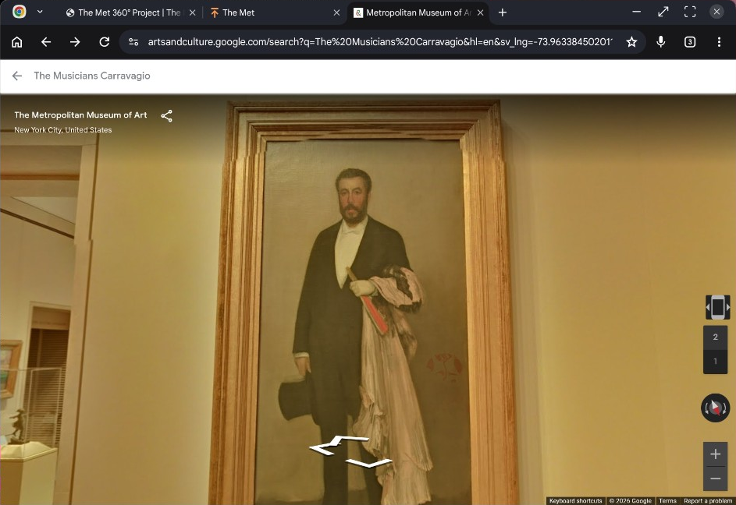
Reference: James McNeill Whistler — Arrangement in Flesh Colour and Black: Portrait of Theodore Duret (1883).
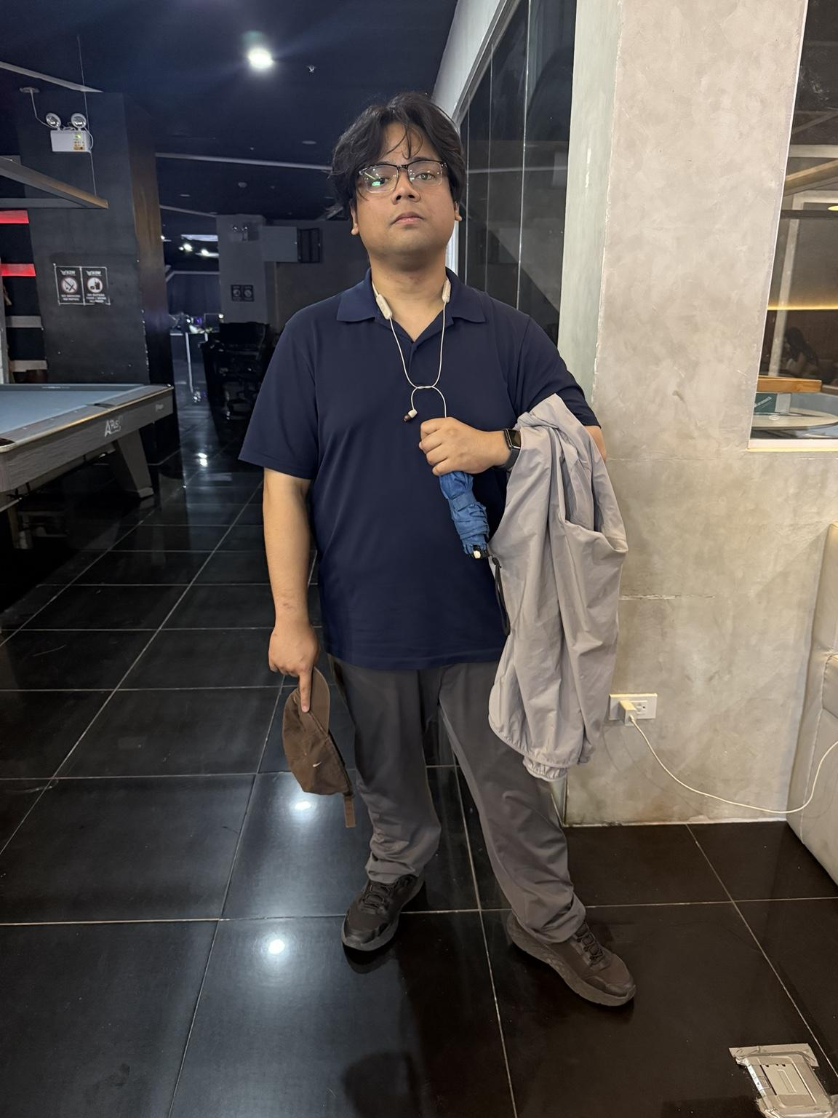
Pose recreation evidence.

Virtual Meme
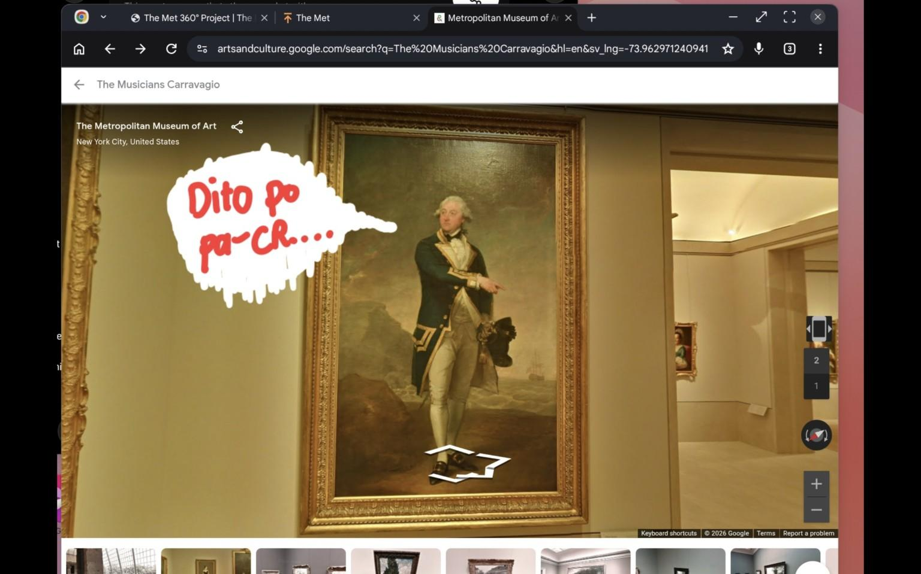
Virtual-tour meme based on Gilbert Stuart's Captain John Gell (1785).

Close-Looking Sketch
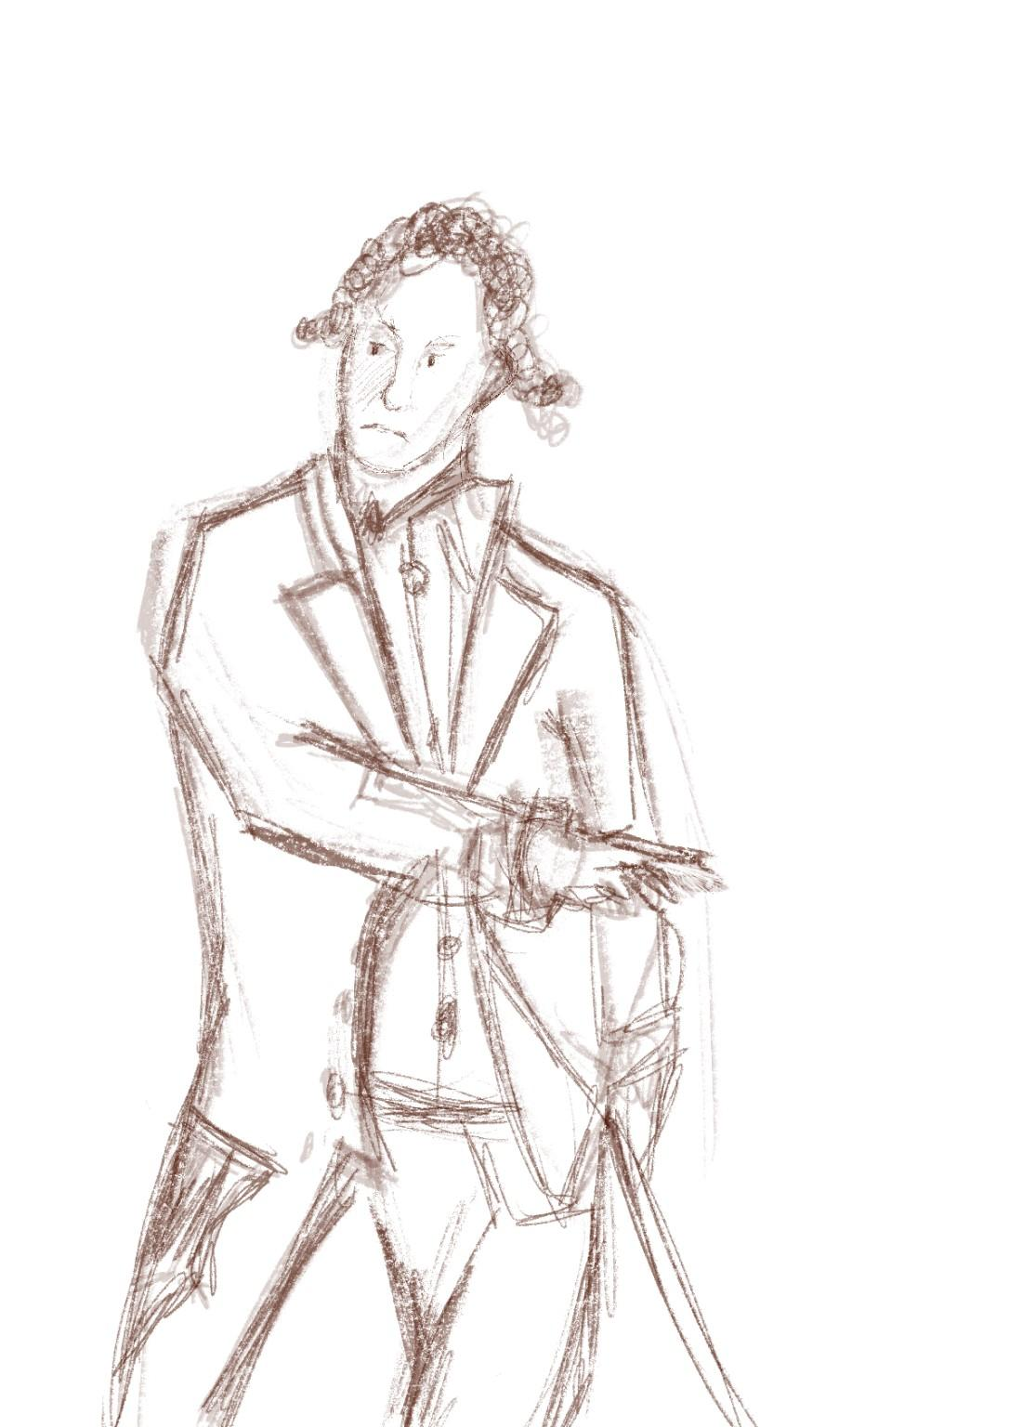
Finished close-looking sketch based on Gilbert Stuart's Captain John Gell (1785).
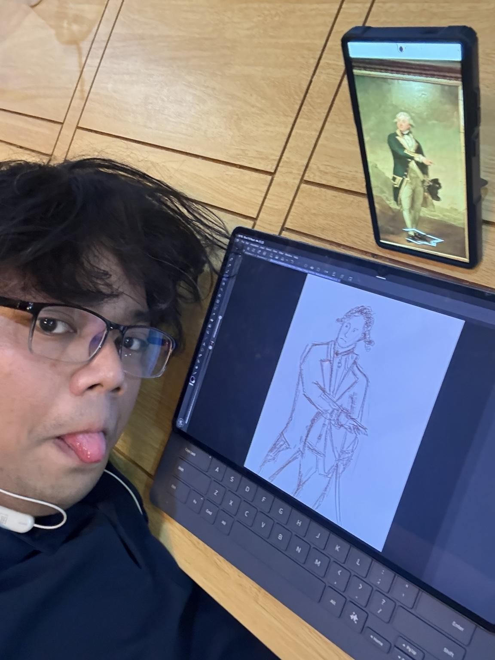
Process evidence with reference artwork visible.

4. Virtual Scavenger Hunt Evidence
Screenshots below were captured from the Metropolitan Museum of Art virtual tour in Google Arts & Culture Street View.

1. Pose like the figure — James McNeill Whistler, Portrait of Theodore Duret (1883).

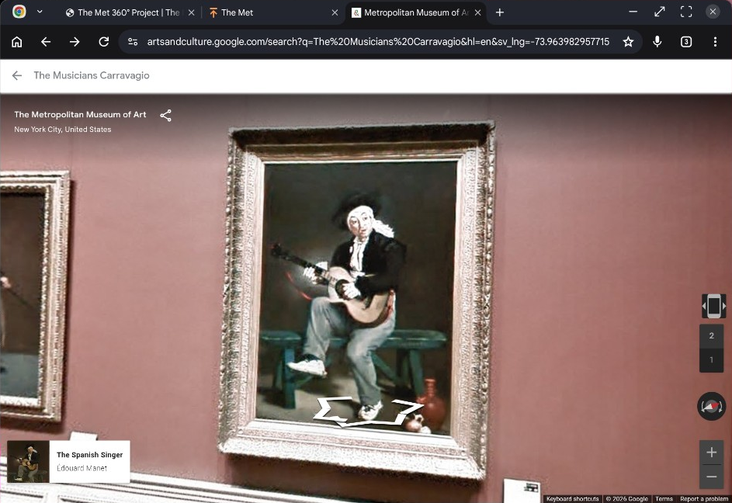
2. Most unusual clothing — Édouard Manet, The Spanish Singer (1860).

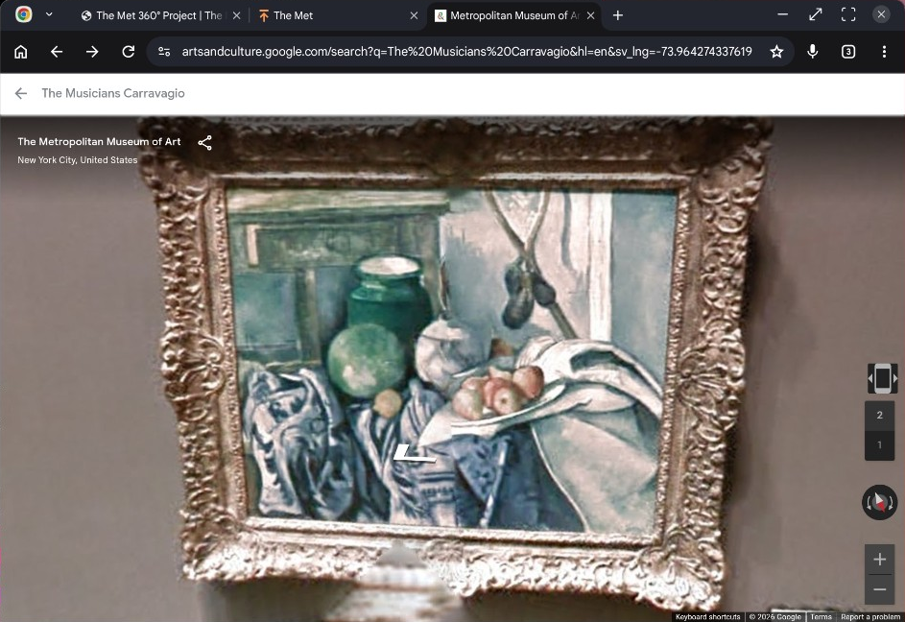
3. Lots of lines or shapes — Paul Cézanne, Still Life with a Ginger Jar and Eggplants (1893–94).

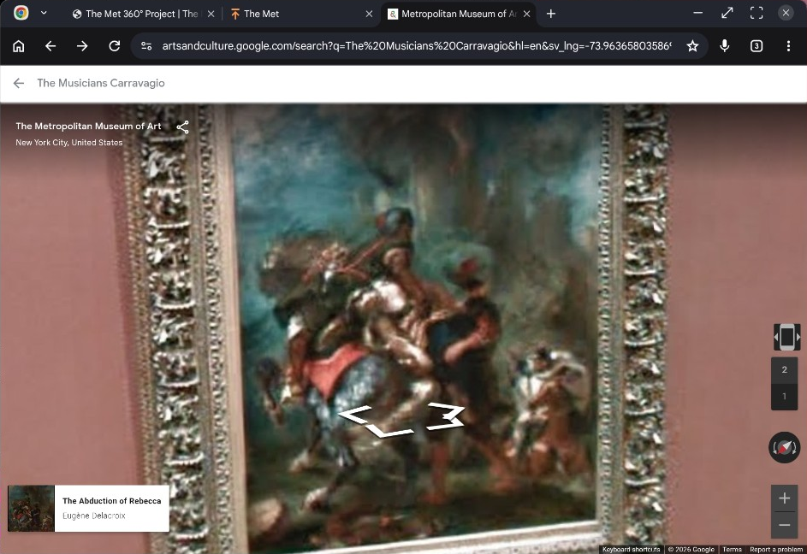
4. Example of perspective — Eugène Delacroix, The Abduction of Rebecca (1846).

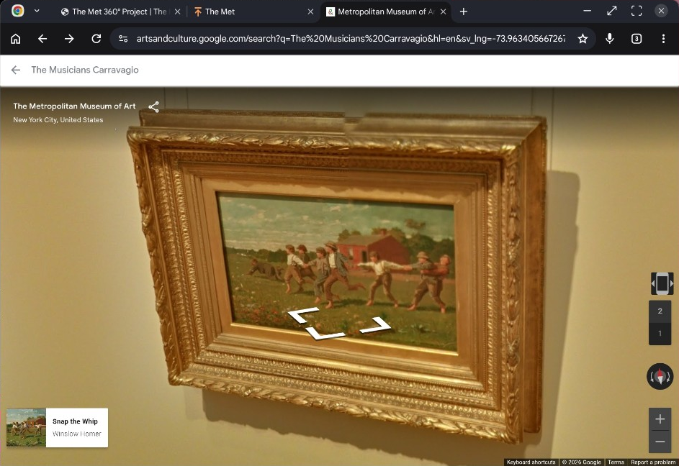
5. Lots of color / very vibrant — Winslow Homer, Snap the Whip (1872).

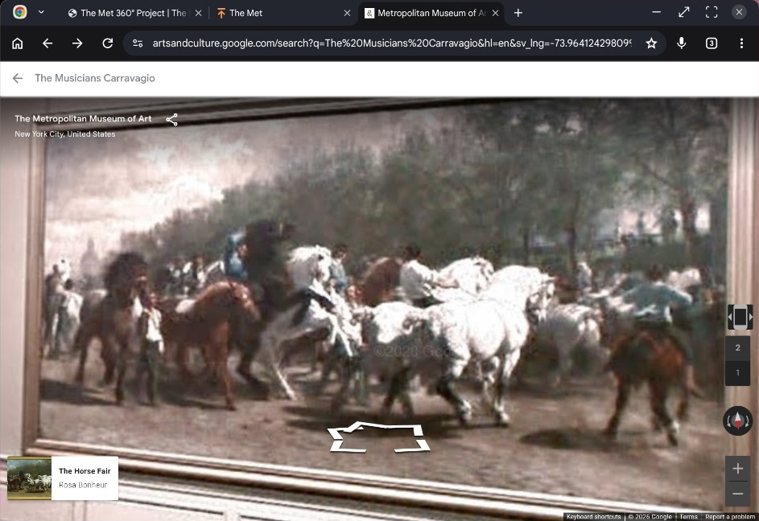
6. Artwork with animals — Rosa Bonheur, The Horse Fair (1852–55).

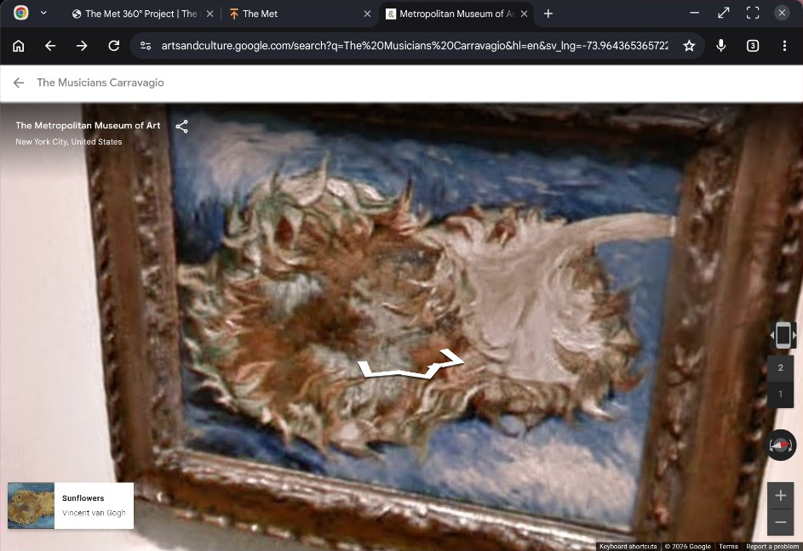
7. Strangest artwork — Vincent van Gogh, Sunflowers (1887).

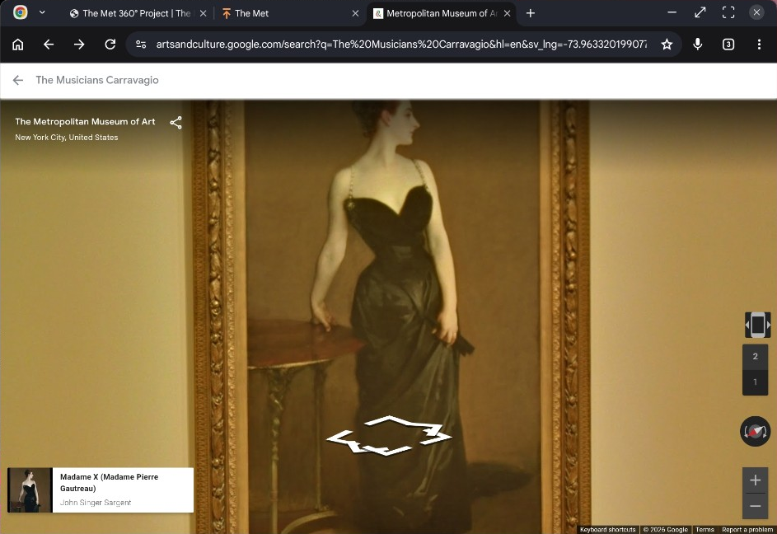
8. Monochromatic artwork — John Singer Sargent, Madame X (1883–84).

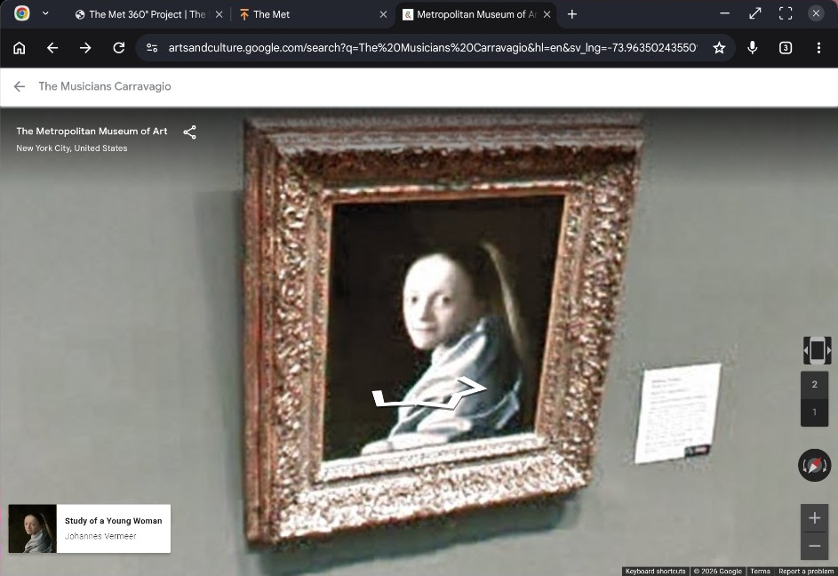
9. Something mysterious — Johannes Vermeer, Study of a Young Woman (ca. 1665–67).

10. Ridiculous artwork — Édouard Manet, The Spanish Singer (1860).

11. Artwork with food — Paul Cézanne, Still Life with a Ginger Jar and Eggplants (1893–94).

12. Interesting texture — Vincent van Gogh, Sunflowers (1887).

13. Craziest expression — Édouard Manet, The Spanish Singer (1860).

14. A painting I would like to be in — Winslow Homer, Snap the Whip (1872).

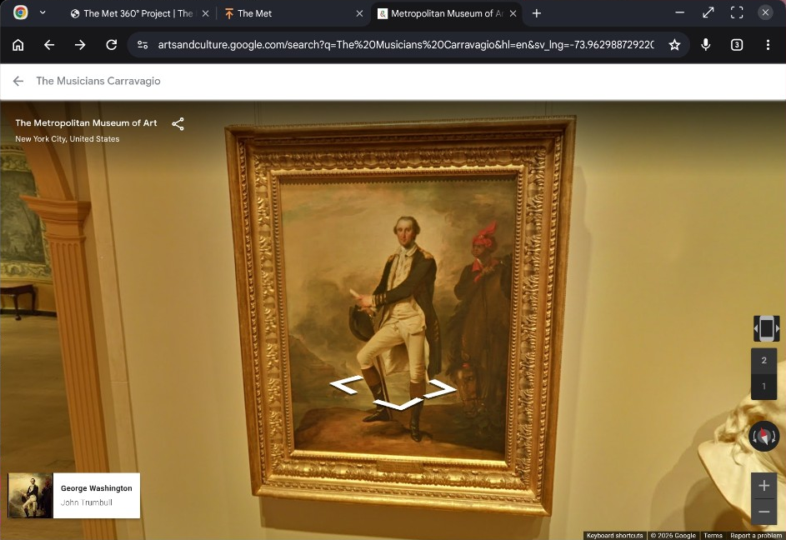
15. A person I would want to have lunch with — John Trumbull, George Washington (1780).

Selected notes
Sunflowers: I chose the sunflowers because I did not quite understand why Van Gogh painted the flowers in that state. Even allowing for colors fading over time, the condition of the flowers in the painting seems intentional, which made me wonder what he was thinking at the time.

Snap the Whip: It reminds me of the days when I could just enjoy existing as is, with no worries and no future to be worried about.

George Washington: I am interested in the parallels I see with Philippine history, particularly Emilio Aguinaldo. I would also be curious about whether lunch was actually a break for someone in his position, or whether planning and work simply continued through it.

5. In-Person Visit Evidence
Selected photographs from the National Museum of Fine Arts visit are included below as proof of attendance, gallery context, and documented artworks.

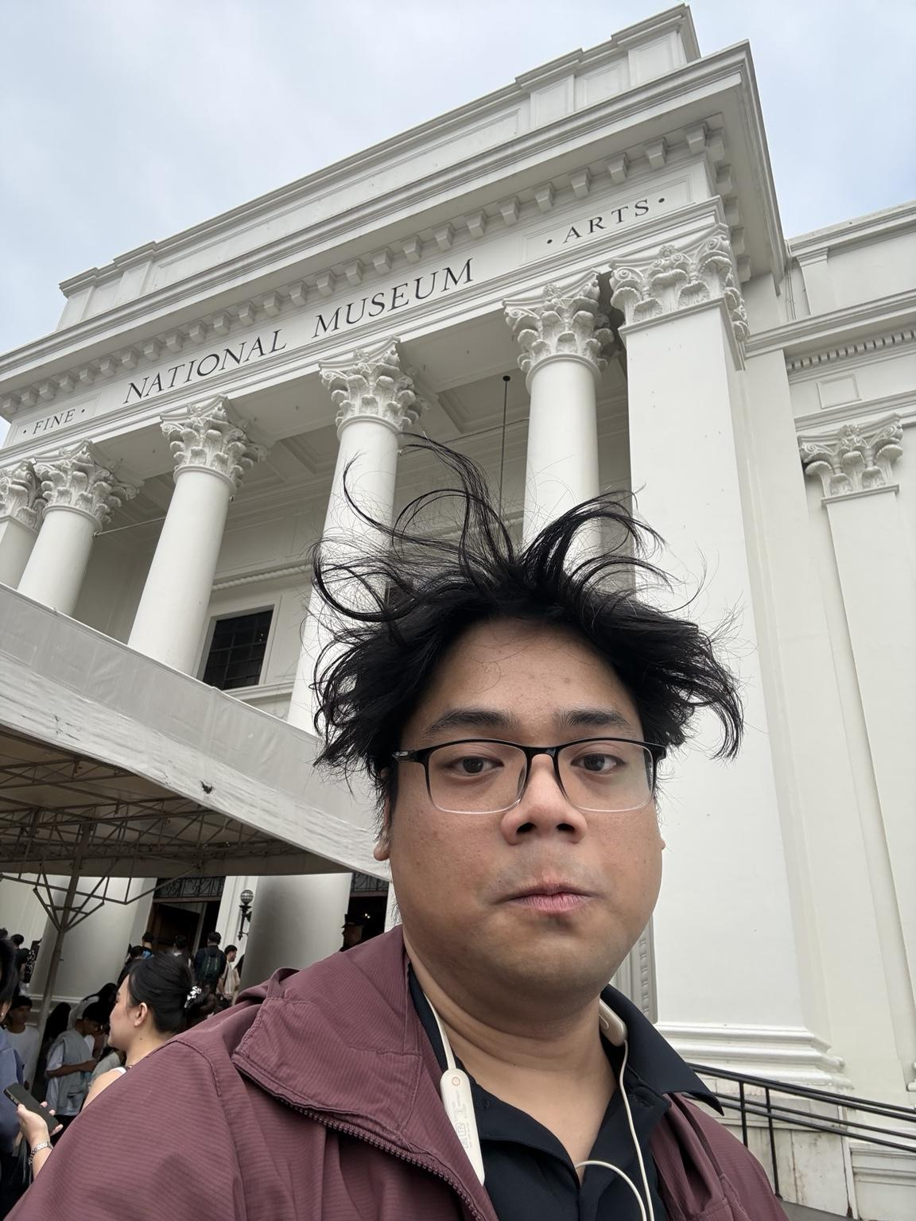
Arrival / personal visit proof outside the National Museum of Fine Arts.

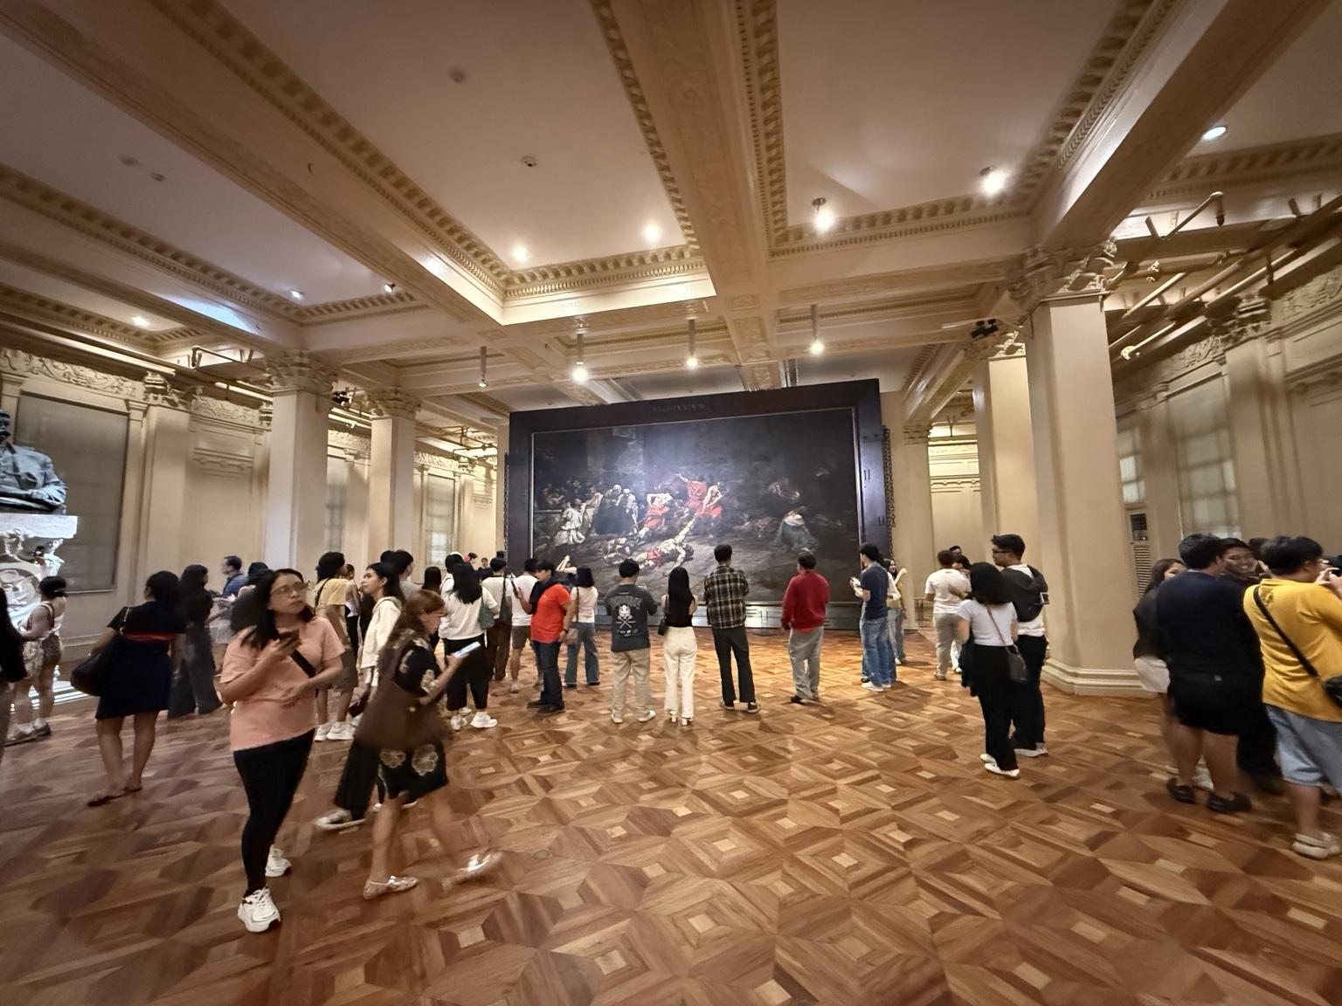
Wide view of the Spoliarium Hall.

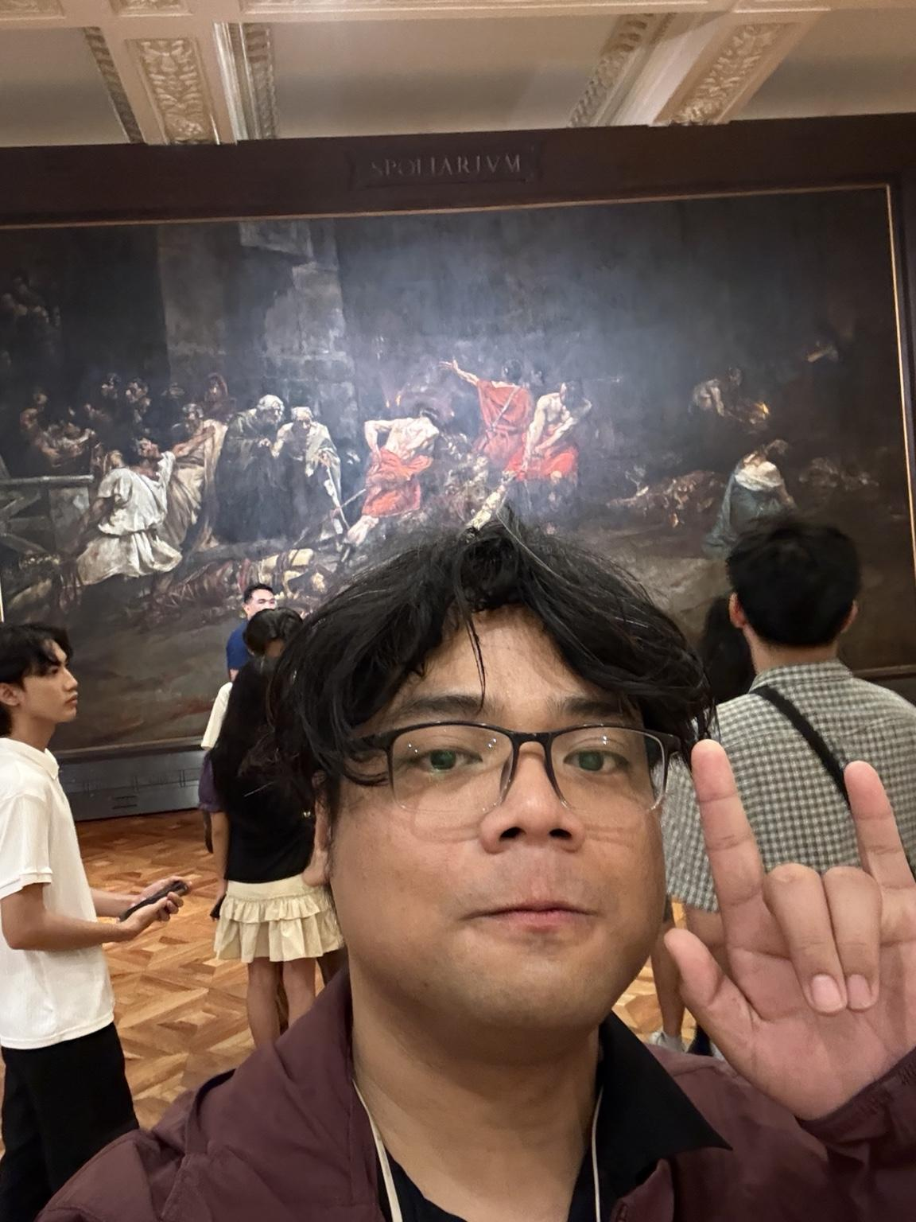
Personal visit evidence inside the Spoliarium Hall.

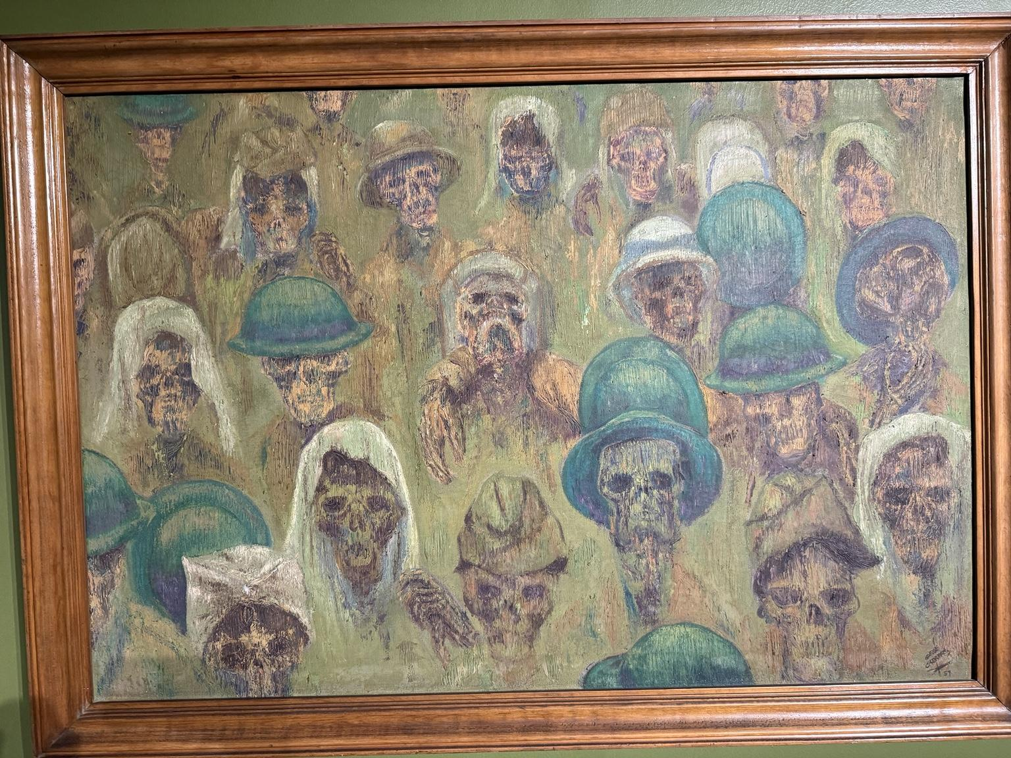
Gene Cabrera — A Tragic Lesson (The Fall of Bataan), 1957.

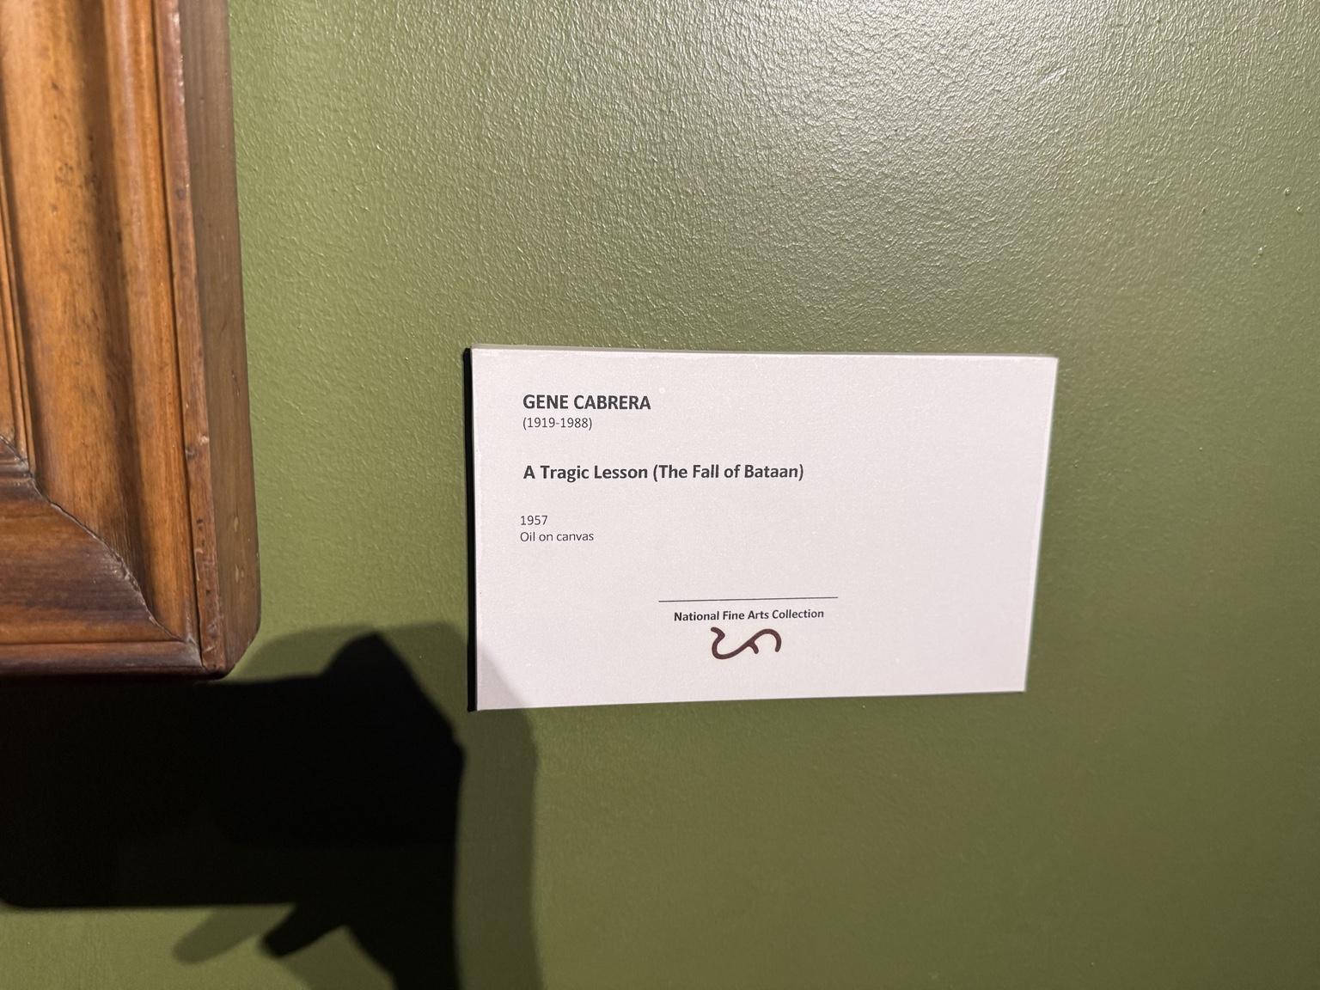
Museum label for A Tragic Lesson (The Fall of Bataan).

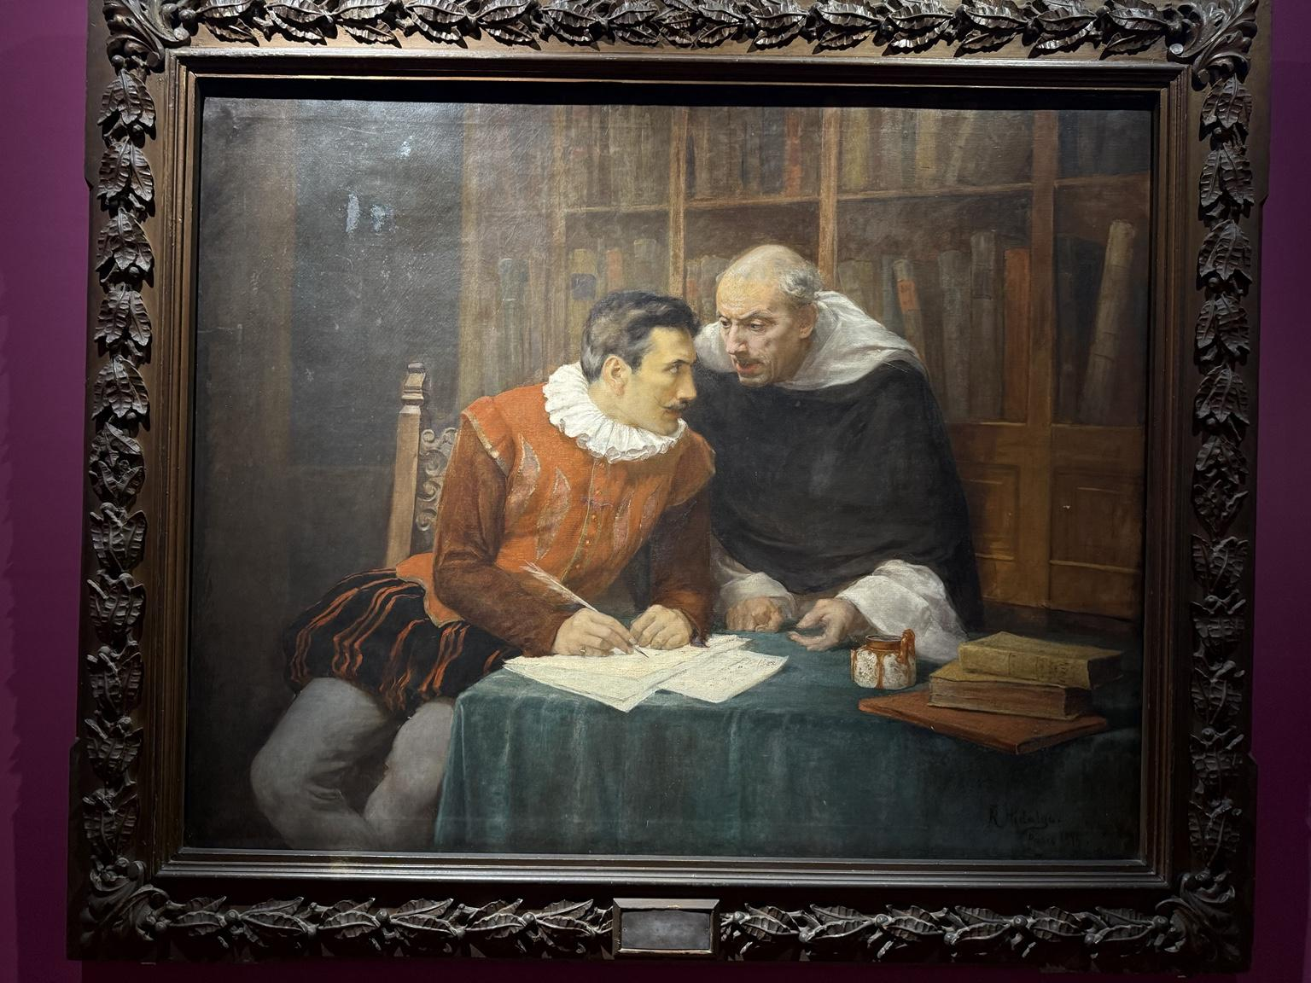
Félix Resurrección Hidalgo — El Gobernador y el Obispo, 1896.

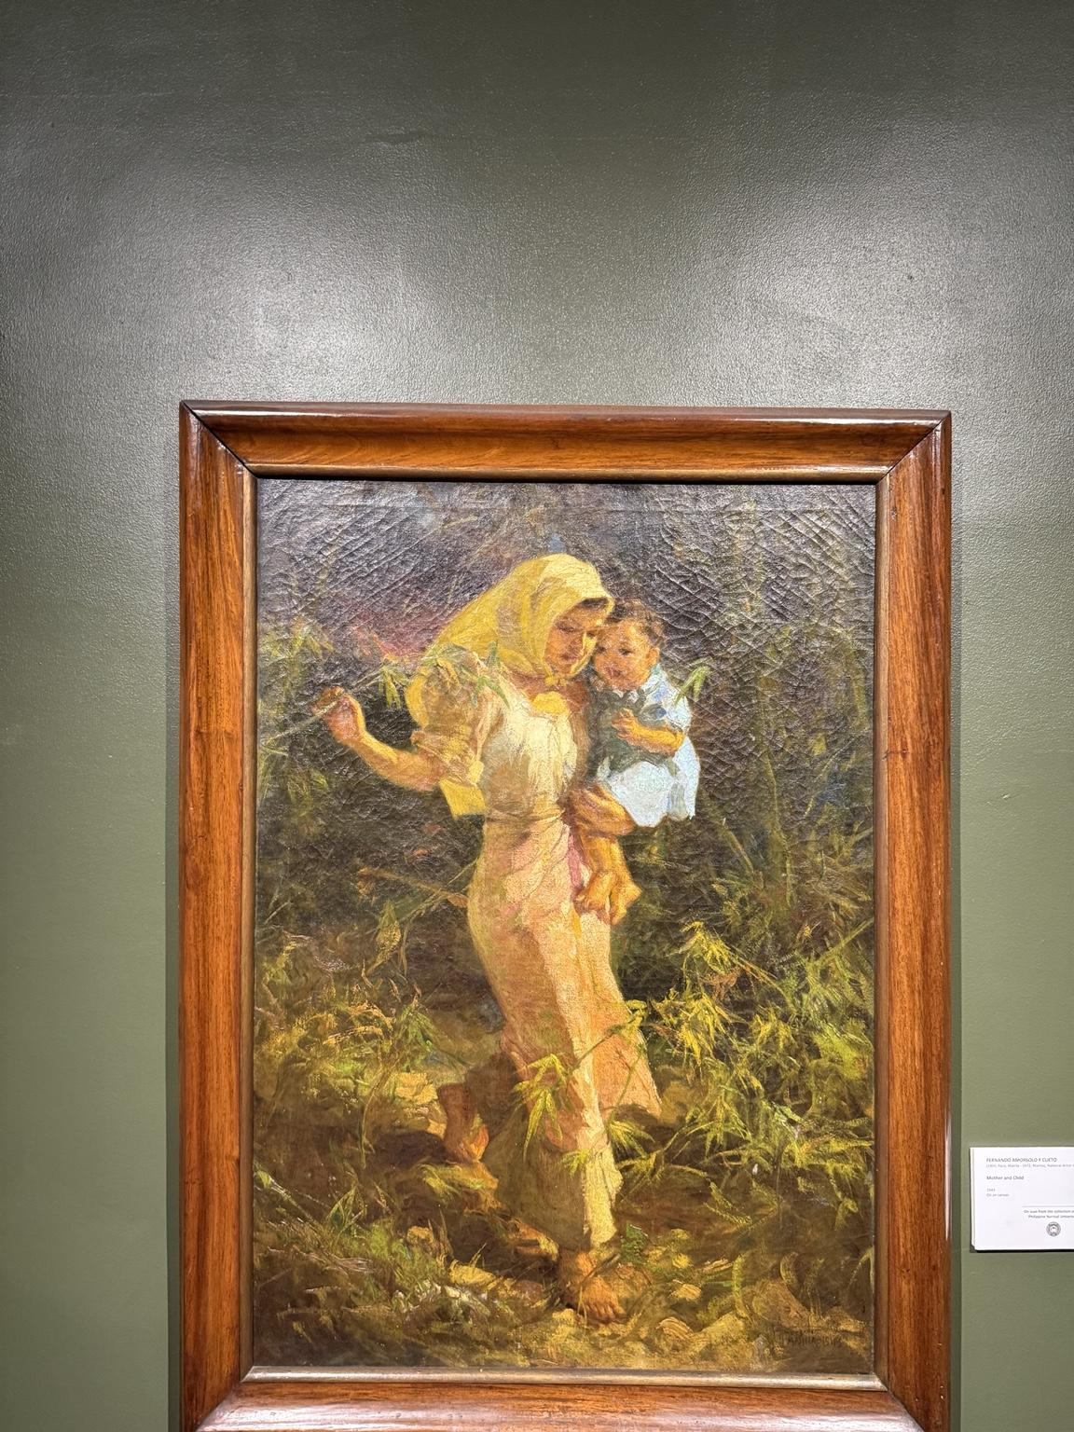
Fernando Amorsolo — Mother and Child, 1943.

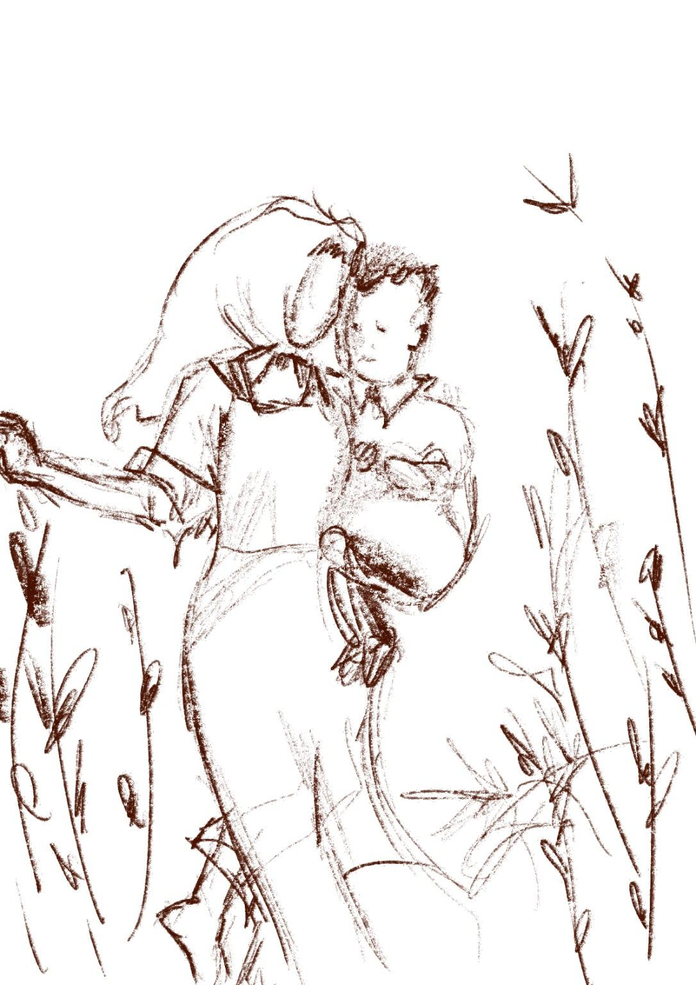
Physical sketch process evidence: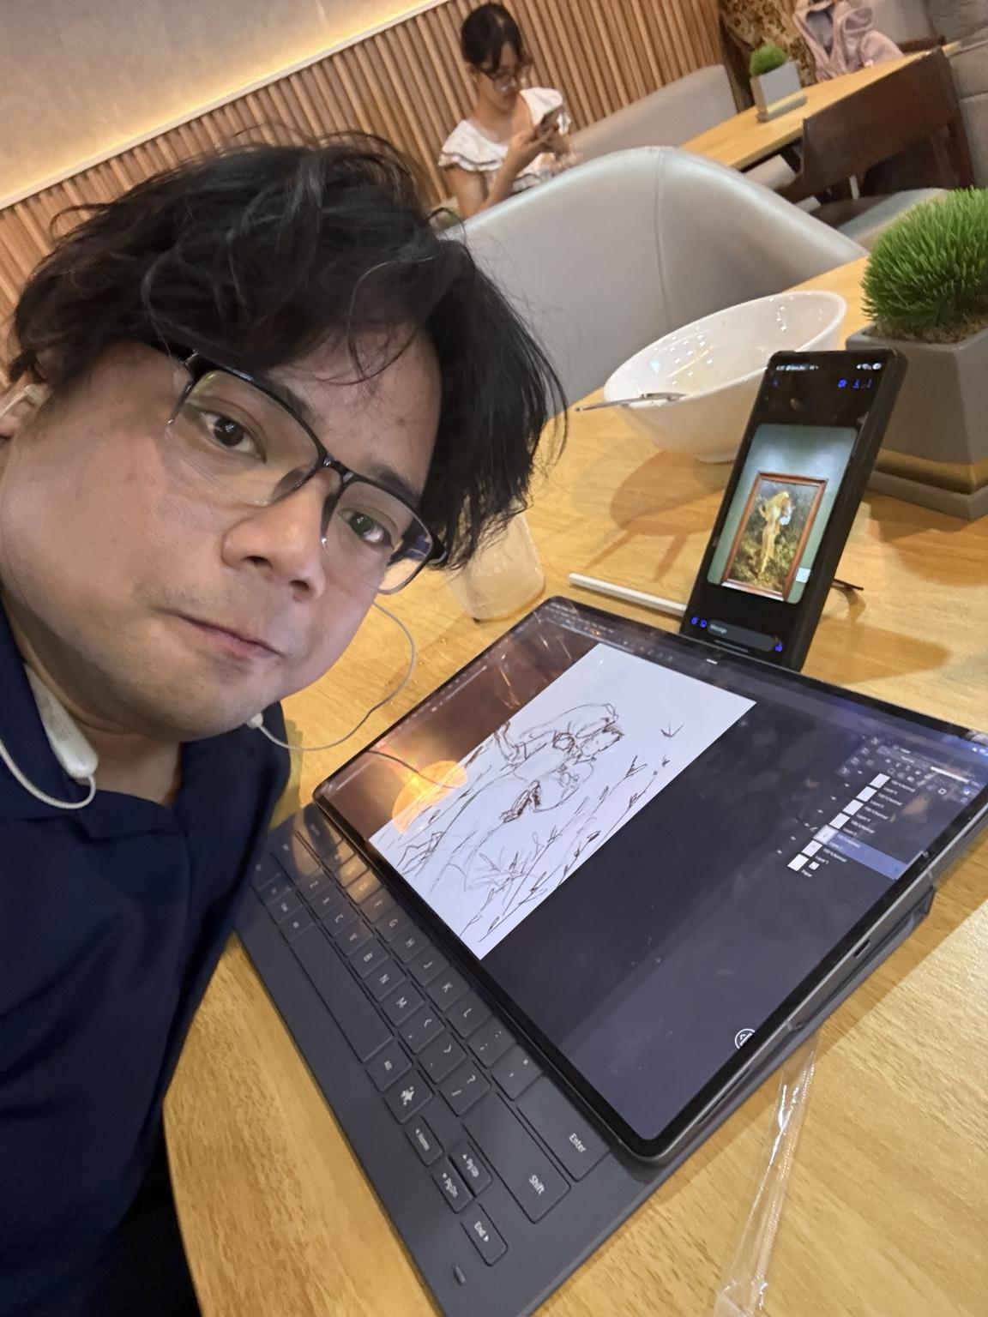

Close-looking sketch based on Amorsolo's Mother and Child.

